**EXPERIMENT-7**

**DEVOPS**

**Aim:** To setup and run Selenium Tests in Jenkins using Maven

**LO:4 -** Examine the importance of Selenium and Jenkins to test software Applications.

**THEORY:**

**Selenium:**

* Selenium tutorial provides basic and advanced concepts of Selenium. Our Selenium tutorial is designed for beginners and professionals.
* Selenium is one of the most widely used open source Web UI (User Interface) automation testing suite.
* Our Selenium tutorial includes all topics of Selenium such as Features, Selenium vs QTP, Selenium Tool Suits, Selenium IDE, Selenium IDE Locating Strategies, Selenium WebDriver, WebDriver Features, WebDriver vs RC, WebDriver Installation, etc.

**Selenium Limitation:**

* Selenium does not support automation testing for desktop applications.
* Selenium requires high skill sets in order to automate tests more effectively.
* Since Selenium is open source software, you have to rely on community forums to get your technical issues resolved.
* We can't perform automation tests on web services like SOAP or REST using Selenium.
* We should know at least one of the supported programming languages to create tests scripts in Selenium WebDriver.
* It does not have built-in Object Repository like UTF/QTP to maintain objects/elements in centralized location. However, we can overcome this limitation using Page Object Model.
* Selenium does not have any inbuilt reporting capability; you have to rely on plug-ins like **JUnit** and **TestNG** for test reports.

**Selenium Features:**

* Selenium is an open source and portable Web testing Framework.
* Selenium IDE provides a playback and record feature for authoring tests without the need to learn a test scripting language.
* It can be considered as the leading cloud-based testing platform which helps testers to record their actions and export them as a reusable script with a simple-to-understand and easy-to-use interface.
* Selenium supports various operating systems, browsers and programming languages. Following is the list:
  + Programming Languages: C#, Java, Python, PHP, Ruby, Perl, and JavaScript
  + Operating Systems: Android, iOS, Windows, Linux, Mac, Solaris.
  + Browsers: Google Chrome, Mozilla Firefox, Internet Explorer, Edge, Opera, Safari, etc.
* It also supports parallel test execution which reduces time and increases the efficiency of tests.

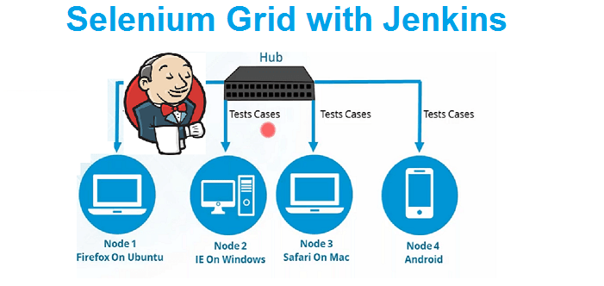

Step 1: Open Jenkins and click on new item.

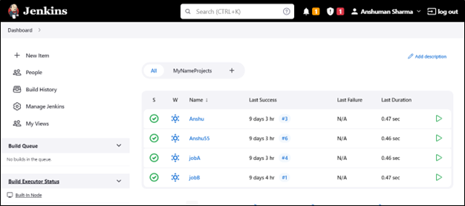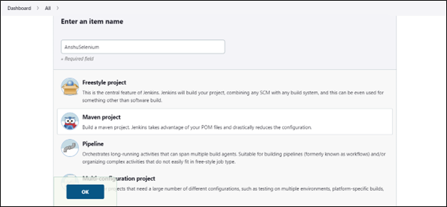

Step 2: Paste the path of the following repository in the source code management.

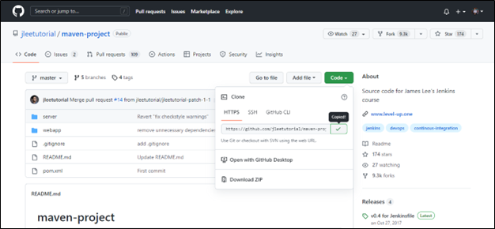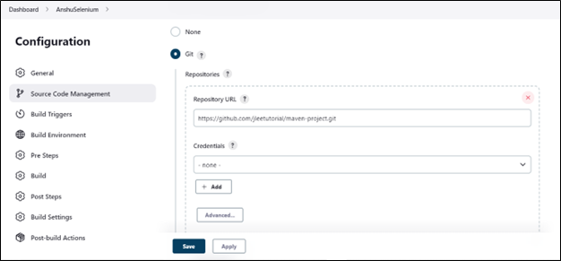

Step 3: write “test” in the goal and options.

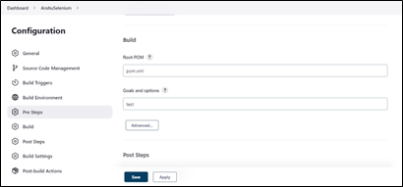

Step 4: Apply and Save.

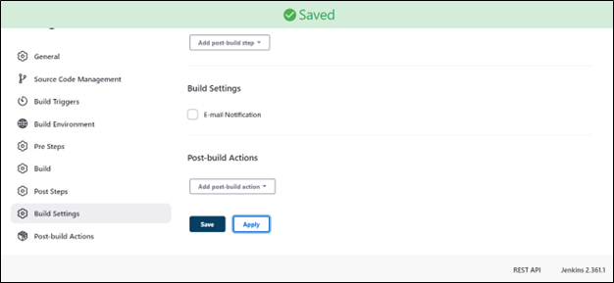

Step 5: Click on the Build Now.

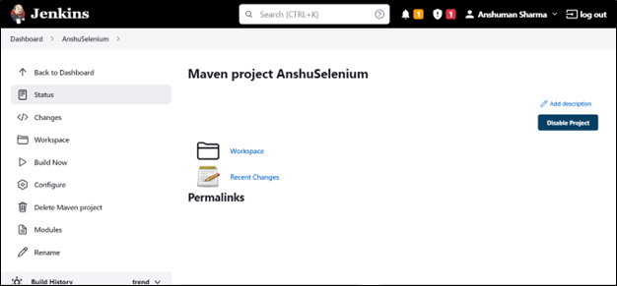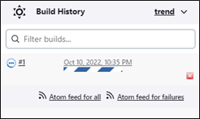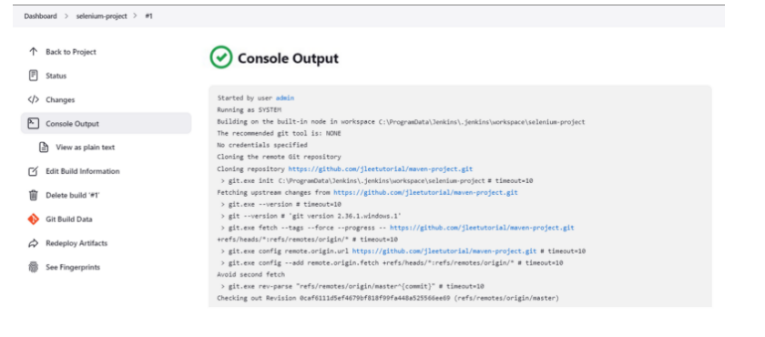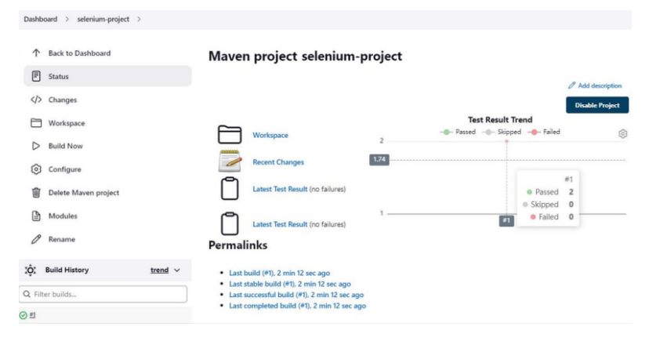

**CONCLUSION:**